**High Level Architecture:**

We will use the MVC architecture for our application.

The **Model** would include a .js file to connect to our MySQL db and provide data whenever required. We will use ‘mysql’ node package for this.

The **View** would contain all our html files, static data (like images, stylesheets etc).

The **Controller** would contain the main app.js file which is the entry point to our application and also the file to route user requests. In addition, it will also contain all the business logic (calculate sales, search algorithms etc).

**Database Organization:**

Our database has 15 tables. The relations and attributes for each of them are defined below:

**Entity Relationship Model (PonyORM)**

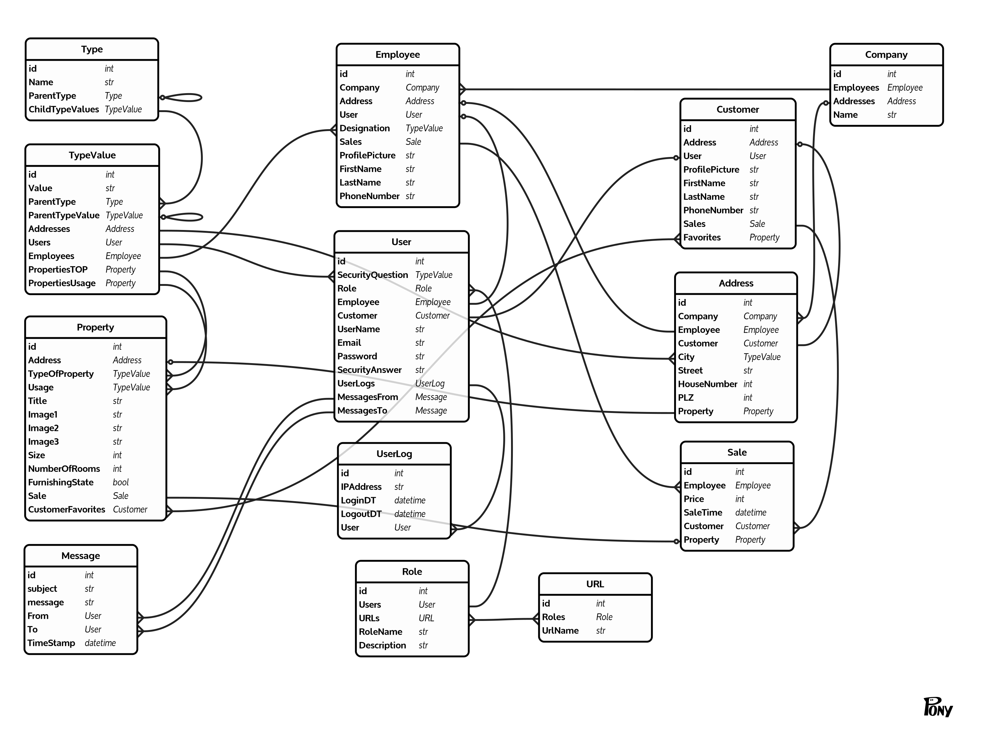

**Entity Relationship Model (MySQL Workbench)**

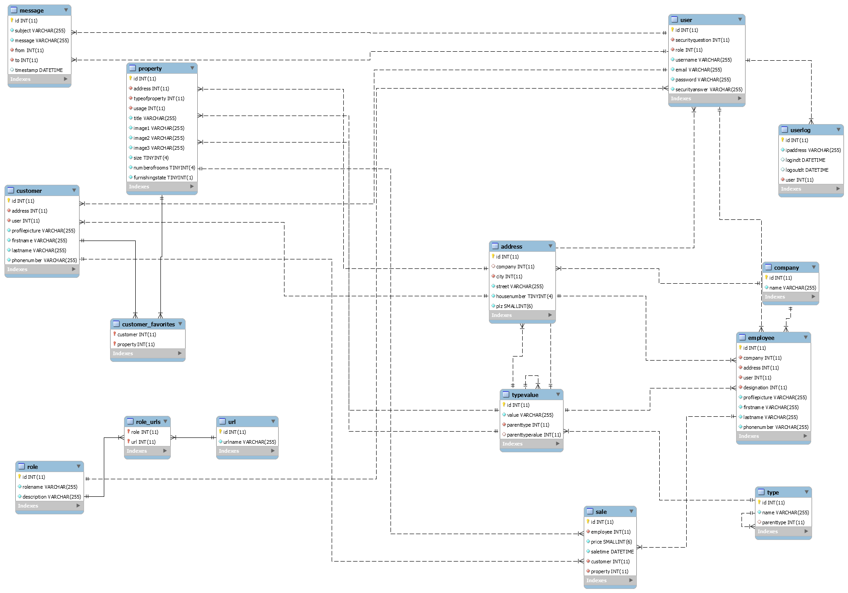

**ENTITIES**

1. **address**

|  |  |  |  |  |  |
| --- | --- | --- | --- | --- | --- |
| **Field** | **Type** | **Null** | **Key** | **Default** | **Extra** |
| id | int(11) | NO | PRI | NULL | auto_increment |
| company | int(11) | YES | MUL | NULL |  |
| city | int(11) | NO | MUL | NULL |  |
| street | varchar(255) | NO |  | NULL |  |
| housenumber | tinyint(4) | NO |  | NULL |  |
| plz | smallint(6) | NO |  | NULL |  |

1. **company**

|  |  |  |  |  |  |
| --- | --- | --- | --- | --- | --- |
| **Field** | **Type** | **Null** | **Key** | **Default** | **Extra** |
| id | int(11) | NO | PRI |  | auto_increment |
| name | varchar(255) | NO |  |  |  |

1. **customer**

|  |  |  |  |  |  |
| --- | --- | --- | --- | --- | --- |
| **Field** | **Type** | **Null** | **Key** | **Default** | **Extra** |
| id | int(11) | NO | PRI |  | auto_increment |
| address | int(11) | NO | MUL |  |  |
| user | int(11) | NO | MUL |  |  |
| profilepicture | varchar(255) | NO |  |  |  |
| firstname | varchar(255) | NO |  |  |  |
| lastname | varchar(255) | NO |  |  |  |
| phonenumber | varchar(255) | NO |  |  |  |

1. **customer_favorites**

|  |  |  |  |  |  |
| --- | --- | --- | --- | --- | --- |
| **Field** | **Type** | **Null** | **Key** | **Default** | **Extra** |
| customer | int(11) | NO | PRI |  |  |
| property | int(11) | NO | PRI |  |  |

1. **employee**

|  |  |  |  |  |  |
| --- | --- | --- | --- | --- | --- |
| **Field** | **Type** | **Null** | **Key** | **Default** | **Extra** |
| id | int(11) | NO | PRI |  | auto_increment |
| company | int(11) | NO | MUL |  |  |
| address | int(11) | NO | MUL |  |  |
| user | int(11) | NO | MUL |  |  |
| designation | int(11) | NO | MUL |  |  |
| profilepicture | varchar(255) | NO |  |  |  |
| firstname | varchar(255) | NO |  |  |  |
| lastname | varchar(255) | NO |  |  |  |
| phonenumber | varchar(255) | NO |  |  |  |

1. **message**

|  |  |  |  |  |  |
| --- | --- | --- | --- | --- | --- |
| **Field** | **Type** | **Null** | **Key** | **Default** | **Extra** |
| id | int(11) | NO | PRI |  | auto_increment |
| subject | varchar(255) | NO |  |  |  |
| message | varchar(255) | NO |  |  |  |
| from | int(11) | NO | MUL |  |  |
| to | int(11) | NO | MUL |  |  |
| timestamp | datetime | YES |  |  |  |

1. **property**

|  |  |  |  |  |  |
| --- | --- | --- | --- | --- | --- |
| **Field** | **Type** | **Null** | **Key** | **Default** | **Extra** |
| id | int(11) | NO | PRI |  | auto_increment |
| address | int(11) | NO | MUL |  |  |
| typeofproperty | int(11) | NO | MUL |  |  |
| usage | int(11) | NO | MUL |  |  |
| title | varchar(255) | NO |  |  |  |
| image1 | varchar(255) | NO |  |  |  |
| image2 | varchar(255) | NO |  |  |  |
| image3 | varchar(255) | NO |  |  |  |
| size | tinyint(4) | NO |  |  |  |
| numberofrooms | tinyint(4) | NO |  |  |  |
| furnishingstate | tinyint(1) | NO |  |  |  |

1. **role**

|  |  |  |  |  |  |
| --- | --- | --- | --- | --- | --- |
| **Field** | **Type** | **Null** | **Key** | **Default** | **Extra** |
| id | int(11) | NO | PRI |  | auto_increment |
| rolename | varchar(255) | NO |  |  |  |
| description | varchar(255) | NO |  |  |  |

1. **role_urls**

|  |  |  |  |  |  |
| --- | --- | --- | --- | --- | --- |
| **Field** | **Type** | **Null** | **Key** | **Default** | **Extra** |
| role | int(11) | NO | PRI |  |  |
| url | int(11) | NO | PRI |  |  |

1. **sale**

|  |  |  |  |  |  |
| --- | --- | --- | --- | --- | --- |
| **Field** | **Type** | **Null** | **Key** | **Default** | **Extra** |
| id | int(11) | NO | PRI |  | auto_increment |
| employee | int(11) | NO | MUL |  |  |
| price | smallint(6) | NO |  |  |  |
| saletime | datetime | NO |  |  |  |
| customer | int(11) | NO | MUL |  |  |
| property | int(11) | NO | MUL |  |  |

1. **type**

|  |  |  |  |  |  |
| --- | --- | --- | --- | --- | --- |
| **Field** | **Type** | **Null** | **Key** | **Default** | **Extra** |
| id | int(11) | NO | PRI |  | auto_increment |
| name | varchar(255) | NO |  |  |  |
| parenttype | int(11) | YES | MUL |  |  |

1. **typevalue**

|  |  |  |  |  |  |
| --- | --- | --- | --- | --- | --- |
| **Field** | **Type** | **Null** | **Key** | **Default** | **Extra** |
| id | int(11) | NO | PRI |  | auto_increment |
| value | varchar(255) | NO |  |  |  |
| parenttype | int(11) | NO | MUL |  |  |
| parenttypevalue | int(11) | YES | MUL |  |  |

1. **url**

|  |  |  |  |  |  |
| --- | --- | --- | --- | --- | --- |
| **Field** | **Type** | **Null** | **Key** | **Default** | **Extra** |
| id | int(11) | NO | PRI |  | auto_increment |
| urlname | varchar(255) | NO |  |  |  |

1. **user**

|  |  |  |  |  |  |
| --- | --- | --- | --- | --- | --- |
| **Field** | **Type** | **Null** | **Key** | **Default** | **Extra** |
| id | int(11) | NO | PRI |  | auto_increment |
| securityquestion | int(11) | NO | MUL |  |  |
| role | int(11) | NO | MUL |  |  |
| username | varchar(255) | NO |  |  |  |
| email | varchar(255) | NO |  |  |  |
| password | varchar(255) | NO |  |  |  |
| securityanswer | varchar(255) | NO |  |  |  |

1. **userlog**

|  |  |  |  |  |  |
| --- | --- | --- | --- | --- | --- |
| **Field** | **Type** | **Null** | **Key** | **Default** | **Extra** |
| id | int(11) | NO | PRI |  | auto_increment |
| ipaddress | varchar(255) | NO |  |  |  |
| logindt | datetime | YES |  |  |  |
| logoutdt | datetime | YES |  |  |  |
| user | int(11) | NO | MUL |  |  |

**REFERENCES**

|  |  |  |  |
| --- | --- | --- | --- |
| **TABLE_NAME** | **COLUMN_NAME** | **REFERENCED_TABLE_NAME** | **REFERENCED_COLUMN_NAME** |
| address | city | typevalue | id |
| address | company | company | id |
| customer | address | address | id |
| customer | user | user | id |
| customer_favorites | customer | customer | id |
| customer_favorites | property | property | id |
| employee | address | address | id |
| employee | company | company | id |
| employee | designation | typevalue | id |
| employee | user | user | id |
| message | from | user | id |
| message | to | user | id |
| property | address | address | id |
| property | typeofproperty | typevalue | id |
| property | usage | typevalue | id |
| role_urls | role | role | id |
| role_urls | url | url | id |
| sale | customer | customer | id |
| sale | employee | employee | id |
| sale | property | property | id |
| type | parenttype | type | id |
| typevalue | parenttype | type | id |
| typevalue | parenttypevalue | typevalue | id |
| user | role | role | id |
| user | securityquestion | typevalue | id |
| userlog | user | user | id |

**Media Storage**Images and video/audio will be kept in file systems and the link to them will be stored in the database table wherever necessary.